Simple game

**Title:** vault robber.

**Genre:** platformer.

**Theme:** robbery.

**Platform and game controls:** computer game. (Something you’d see in cool maths games or other sites like it) the games controls are the arrow keys to move, the spacebar to jump and left click to interact. (Will elaborate further down)

**Narrative/objective design:** like the name suggests its about you playing as a robber robbing a vault guarded by security cameras and alarm lasers. You need disable the cameras and depending on the level, the lasers.

**Character design:** the design is a generic robber with a black hat, face mask, black trousers, black bag and a black and white stripe t-shirt.

**Level/environment design:** it takes place in a bank during the night with white walls and pillars with black floors, security cameras on the ceiling or walls moving left and right or up and down and alarm lasers dotted around. The vault itself is on the other side of the level. The overall structure depends on the level with it getting bigger and more complex. Most levels require you to jump on platforms to reach places you need to go.

**Game mechanics/gameplay design:** the aim of the game is to reach the vault by avoiding cameras which have beams to show their vision and alarm lasers by jumping over them or if you can’t you find rooms that have switches to turn them off then you can proceed to the vault and once there you win. Naturally if you get caught by the lasers or cameras you lose. The levels get more platformy as you progress threw the game and if will make you time jumps to platforms to avoid moving cameras.

bob the robber 4 has the same camera mechanic.

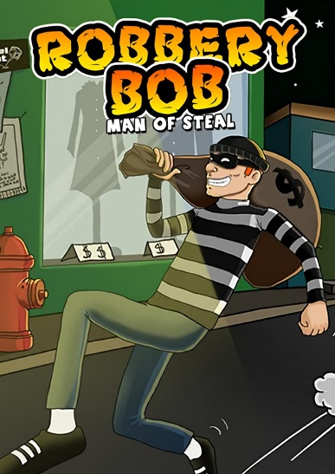

Robbery bob has the same generic robber design.

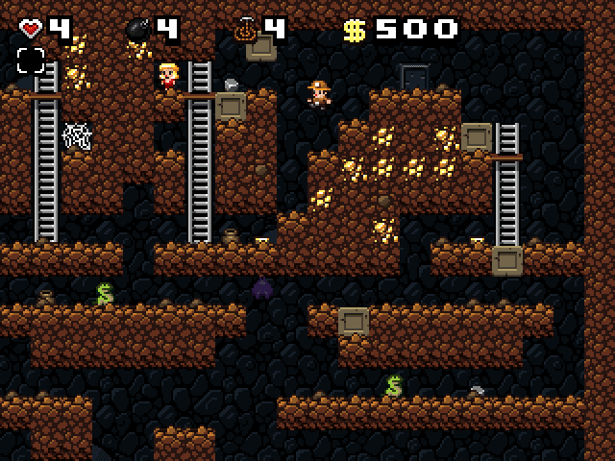

this game has a rough idea of the platform layout

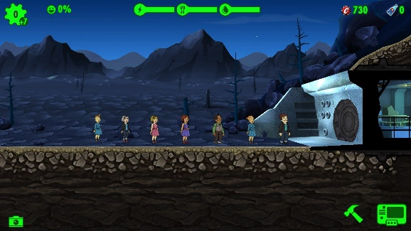fallout shelter has a vault (not the same kind of vault but a vault non the less)